Cryogenic Near Infra-Red Spectro-Polarimeter (Cryo-NIRSP):

Principal Investigator: Jeff Kuhn, Institute for Astronomy, University of Hawaii
Instrument Scientist: Andre Fehlmann, DKIST, National Solar Observatory\
Instrument Summary Article: Fehlmann et al. (2023) Solar Physics, V298, 5

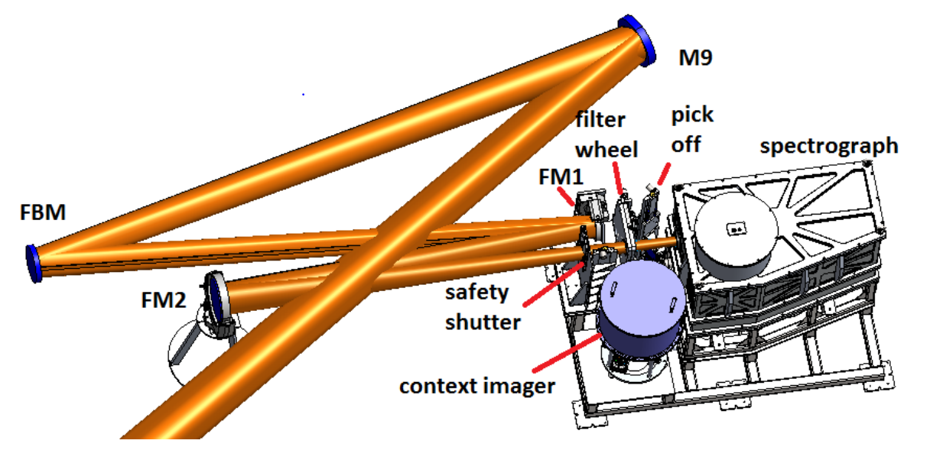 | The Cryo-NIRSP takes advantage of the full coronagraphic capabilities of DKIST to observe both the near-limb and off-limb corona out to 1.5 Solar Radii. It consists of a single slit spectropolarimeter and a context imager that measure the polarization state of spectral lines between 1000 and 5000 nm. To reduce the thermal IR background, it operates at cryogenic temperatures. It can also target on-disk targets, e.g. using the fundamental CO band at 4651 nm.

Important note: Please refer to the latest DKIST Observing Cycle Proposal Call document for the definition of available instrument modes. The information below is a summary of the instrument capabilities as designed and does not necessarily reflect the modes available.

Spatial Field of View and Resolution:
Optical: 5' (arcmin) round accessible field-of-regard for off-limb targets
4' x 3' for near-limb targets using limb occulter at Gregorian telescope focus
2' square for on-disk targets
Along slit: 0.12'' per pixel sampling.
Slit widths: Two options: 0.15'' or 0.5'', nominally used for on-disk and coronal use cases respectively.
Slit length: 4' for off-limb and near-limb targets (using the 0.5'' wide slit)
120'' for on-disk targets (using the 0.15'' wide slit)
Context imager: 100'' x 100'' (centered on spectrograph slit); 0.052'' per pixel sampling

- The 0.15'' slit critically samples diffraction limited resolution at 4770 nm (1.22 λ/D -> 0.3'')
- Image stability to better than 1 arcsecond rms. Cryo-NIRSP is not supported by DKIST adaptive optics.
- Scanning mirror simultaneously scans solar image across slit and context imager.
- Solar image can be scanned both parallel and perpendicular to spectrograph slit allowing full field coverage.
- The slit orientation for a single scanned observation can be freely rotated with respect to the solar image.

Spectral Range and Resolution:
- Spectral range: 1000 to 5000 nm
- Spectral resolution: Better than R ~ 30000 using 0.5'' slit; better than R~100000 for 0.15'' slit
- See tables below for available spectrograph order-sorting filters and context imager filters. Cryo-NIRSP can observe only one single spectral line at a time. Not all wavelengths have been commissioned.

Temporal Cadence:
- Must be calculated based on required S/N and resolution using the Instrument Performance Calculator.
- Dual beam polarization modulation with up to 10 Hz camera frame rate.
- <30 seconds required to change spectrograph wavelength.
Polarimetric Capabilities and Accuracy:
- Spectrograph: Full Stokes vector (dual-beam) polarimetry
- 5 x 10⁻⁴ P/I_{cont} polarimetric accuracy (assuming 10 second integration on disk)
- Intensity-only spectroscopy also available.

Photometric Capabilities (Precision):
- Low background thermal emission: 10 millionths of disk brightness at Si IX 3934 nm coronal line.
- Total efficiency greater than or equal to 10%

Spectrograph Details:
- Detector: H2RG 2048x2048 pixels, 18-micron pitch.
- The 4' long slit covers all 2048 pixels in the spatial dimension, and the dual beam spectra are located on separate halves of the array.
- The 120'' slit spectra extends across 1034 pixels along the slit.

Table: Spectrograph order sorting filters with performance estimates: Spectral range is over 1024 detector pixels.
Filter center wavelength [nm] | Filter FWHM [nm] | Range on detector [nm] | Grating Order | 0.15'' x 120'' slit  (52 um x 42 mm physical) |  | 0.5'' x 240'' slit  (175 um x 81 mm physical)
 |  |  |  | Spectral resolution[pm] | Resolving power (R) | Spectral resolution[pm] | Resolving power (R)
854 | 12 | 3.4 | 66 | 6.3 | 123,253 | 21.2 | 40,256
1077 | 20 | 4.4 | 52 | 8.1 | 122,539 | 27.1 | ﻿40,068
1252 | 27 | 5.0 | 45 | 9.3 | 122,794 | 31.2 | 40,140
1282 | 28 | 5.1 | 44 | 9.4 | 123,478 | 31.8 | 40,320
1430 | 35 | 5.2 | 40 | 10.7 | 133,697 | 33.3 | 42,930
2218 | 43 | 7.6 | 26 | 14.8 | 140,222 | 49.7 | 44,632
3028 | 70 | 10.4 | 19 | 20.5 | 137,995 | 68.4 | 44,099
3934 | 124 | 17.8 | 14 | 36.0 | 109,376 | 107.1 | 36,744
4651 | 171 | 19.7 | 12 | 40.1 | 116,117 | 120.6 | 38,576

Context Imager:
H2RG 2048 x 2048 pixels, 18 micron pitch. The entire array is used during imaging observations.
Context imager filters:
Filter center wavelength [nm] | Filter FWHM [nm] | Spectral Lines/Region
1049.5 | 1.0 | Continuum (for background subtraction)
1074.7 | 1.0 | Fe XIII (1)
1079.8 | 1.0 | Fe XIII (2)
1083.0 | 1.0 | He I
1281.8 | 1.0 | H paschen beta
1250.0 | 160.0 | J Band
1430.0 | 1.0 | Si X

Primary Spectral Diagnostics Available
Ion | Wavelength [nm] | Char. Log(T) [K] | Lande  geff | Transition(s) | Potential Application Notes
Fe XIII | 1074.7 | 6.22 | 1.5 | 3s² 3p² ³P_{0->1} | Coronal intensity/velocity/line widths  Long. magnetic field strength (Stokes V)  Azimuthal field projection (Stokes Q/U)  Densities using ratio of Fe XIII lines.
Fe XIII | 1079.7 | 6.22 | 1.5 | 3s² 3p² ³P_{1->2} | Coronal intensity/velocity/line widths  Long. magnetic field strength (Stokes V)  Azimuthal field projection (Stokes Q/U)  Densities using ratio of Fe XIII lines.
He I Triplet | 1082.909  1083.250  1083.034 | ~4 | 2.0  1.75  1.25 | 1s 2s ³S₁ - 1s 2p ³P₀  1s 2s ³S₁ - 1s 2p ³P₁  1s 2s ³S₁ - 1s 2p ³P₂ | Chromospheric intensity/velocity  Zeeman/Hanle magnetic field measurements  Dusty corona potential with Hanle effect
Si X | 1430 | 6.13 | 1.5 | 2s² 2p ²P_{1/2->3/2} | Coronal intensity/velocity/line widths  Long. magnetic field strength (Stokes V)  Azimuthal field projection (Stokes Q/U)
Si IX | 3935 | 6.04 | 1.5 | 2s² 2p² ³P_{0->1} | Coronal intensity/velocity/line widths  Long. magnetic field strength (Stokes V)  Azimuthal field projection (Stokes Q/U)  Densities using ratio of Si IX lines
CO | 4651 | <3.63 | 1.5 | CO fundamental band | Molecular formation in temperature minimum regions

Instrument Modes

Targeting modes: On-disk
Near-limb with limb occulted at telescope’s Gregorian focus (+/- 5'' occulting)
Near-limb without limb occulter
Off-limb (solar disk entirely inverse occulted at prime telescope focus. Max. pointing at 1.5 R_sun)
Pick-off mirror modes: Pellicle: Simultaneous spectrograph and context image observations
Clear: Only spectrograph observations (no context imager)
Mirror: Only context imager observations.
Polarimetry: Full-stokes spectropolarimetry
Stokes-I spectroscopy

Data Structure

Maps of polarized line spectra (IQUV or I-only) of selected FOV with selected step size and number of steps
Context images at selected wavelengths over FOV centered at each slit position.

Example Modes of Operation

It is important to note that the Cryo-NIRSP instrument is designed for operational flexibility to meet a range of research needs, both those currently known and well understood and many unknown or only poorly understood. The instrument thus aims to serve a wide range of exploratory science, and the use cases below are only examples.
Disk/limb observation:
Scan 90x90 arcsec field of view (70 arcsec on limb, 20 arcsec off-limb) at CO wavelength of 4.65 um with a cadence of 90 seconds. This yields 4 maps of polarized (IQUV) line profiles with a resolution of 100,000 and seeing limited spatial resolution of one arcsec.
Near limb observation:
Scan of 4x3 arcmin with 1 arcsec spatial and R=30,000 spectral resolution tangent to limb that includes prominence with a cadence of 2 hours. Obtain context image after each full spectral scan and then switch wavelength. This yield 4 maps of polarized (IQUV) line profiles for each wavelength.

Off-limb observation:
Scan 4x3 arcmin region 10arcsec above limb active region with 1 arcsec resolution and 30 minutes cadence. Obtain context image at 3.93 microns and Stokes Q context image once per field scan. This yields 4 maps of polarized (IQUV) line profiles and two context images.

Special Notes

Cryo-NIRSP cannot be operated simultaneously with other DKIST instruments. The time to switch between Cryo-NIRSP observations and the post-AO instruments is ~> 30 minutes.

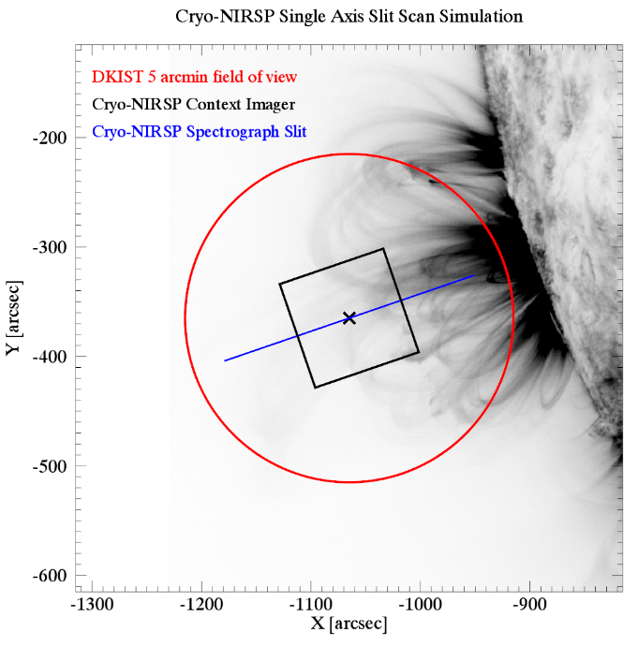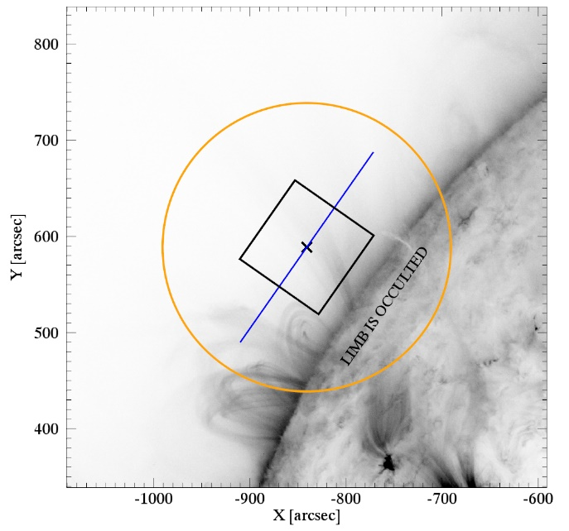
1 Example off-limb (left) and near-limb (right) pointing overplotted on a representative SDO/AIA 171Å image (inverted color scale) . The 5 arcminute optical field of view (red/orange) is defined by the telescope’s field stop. The black box represents the 100’’ x 100’’ context imager FOV while the blue line represents the 4 arcminute long slit (0.5’’ slit width). The solar image can be scanned across the slit/context imager in 2 different directions (parallel and perpendicular to the slit).

